TEMPLATE FOR EXTENDED ABSTRACT 13TH ****SEMINAR ON SCIENCE & TECHNOLOGY (S&T 2020)****

***(TIMES NEW ROMAN, 14 FONT SIZE, BOLD, ALL CAPS, CENTERED)***

First A. Author*1, Second B. Author2 and Third C. Author3 *(12 font size)*

1, 2 Authors’ Department, Institute, Organisation, Country *(11 font size)*

Email

3 Author’s Department, Institute, Organisation, Country

Email

***Abstract:*** Abstract should be written with 11 font size, Times New Roman, justified, single line spacing. The abstract should be concise and should contain no more than 300 words. Objecives, methods and findings are summarized in this section

***Keywords*:**This section should contain maximum 5 words separated by commas.

1. **INTRODUCTION** (Title Times New Roman, 12 font size, bold).

Current literature regarding the work subject should be examined and the differences of the said work from the past, similar works should be presented clearly in the introduction section.

1. **METHODOLOGY**

The methodology must be clearly stated and described in sufficient detail or with sufficient references. The author shall explain the research question, describe the research framework, and the methods applied in detail. It should be furthermore highlighted why the research question is relevant to theory and practice, and why the chosen method(s) are suited for the problem.

* 1. **Subtitle**

First degree titles (2.) should be written left aligned, all caps and bold. Second and 3rd degree subtitles (2.1, 2.1.1) should be written left aligned, bold and with title case. A blank line should be placed between the paragraphs and there should not be any paragraph indentation.

1. **RESULTS & DISCUSSION**

Presentation of the result obtained. If possible, use descriptive figures or tables rather than explain in text. Do not discuss or interpret the results at this stage. Discuss the results. Put your results in perspective by comparing to other studies or generally accepted knowledge in the field. Criticize your own method and results, for example, with respect to the simplifications made.

**3.1 Subtitles**

Supporting figures, tables and images may be included. All the tables, images and figures should be centered. Figures and images should be numbered and figure captions should be placed under the figure or image. Please see Figure 1 for an example. The tables should also be numbered and the table caption should be placed at the top. Please see Table 1 for an example.

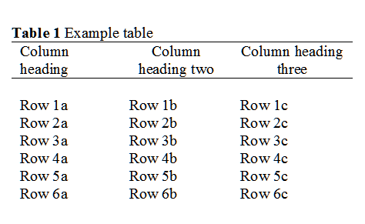

Table 1: Example Table



**Figure 1.** Example graph for the extended abstract.

1. **CONCLUSION**

Please conclude your work incorporating your most important finding as well as future works (3-4 lines).

**ACKNOWLEDGEMENT**

# Please acknowledge your research grant, organization, scholarship (where relevant).

# REFERENCES

References that have been presented inside (Authors, Year) in the full text should be prepared in the format of IEEE as shown below:

[1] James, H. (1937). The ambassadors. New York, NY: Scribner.

[2] Smith, T., Jones, M.: 'The title of the paper', IET Syst. Biol., 2007, 1, (2), pp. 1–7

[3] Borwn, L., Thomas, H., James, C., et al.:'The title of the paper, IET Communications, 2012, 6, (5), pp 125-138

[4] Hodges, A., Smith, N.: 'The title of the book chapter', in Brown, S. (Ed.): 'Handbook of Systems Biology' (IEE Press, 2004, 1st edn.), pp. 1–7